**Exercise 2:**

Using Language Understanding (LUIS) in your Bot

1. Go to Azure Portal, Select **Create new resource** in the Menu blade and Click **See all**.

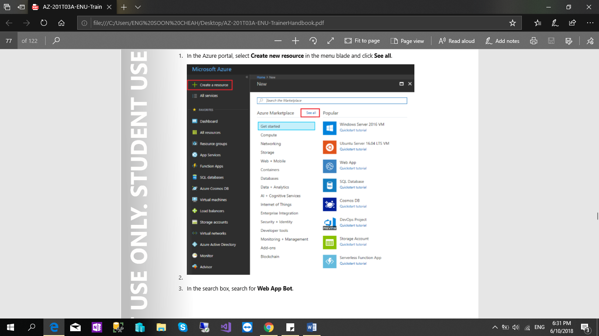

1. In the search box, search for **Web App Bot**.

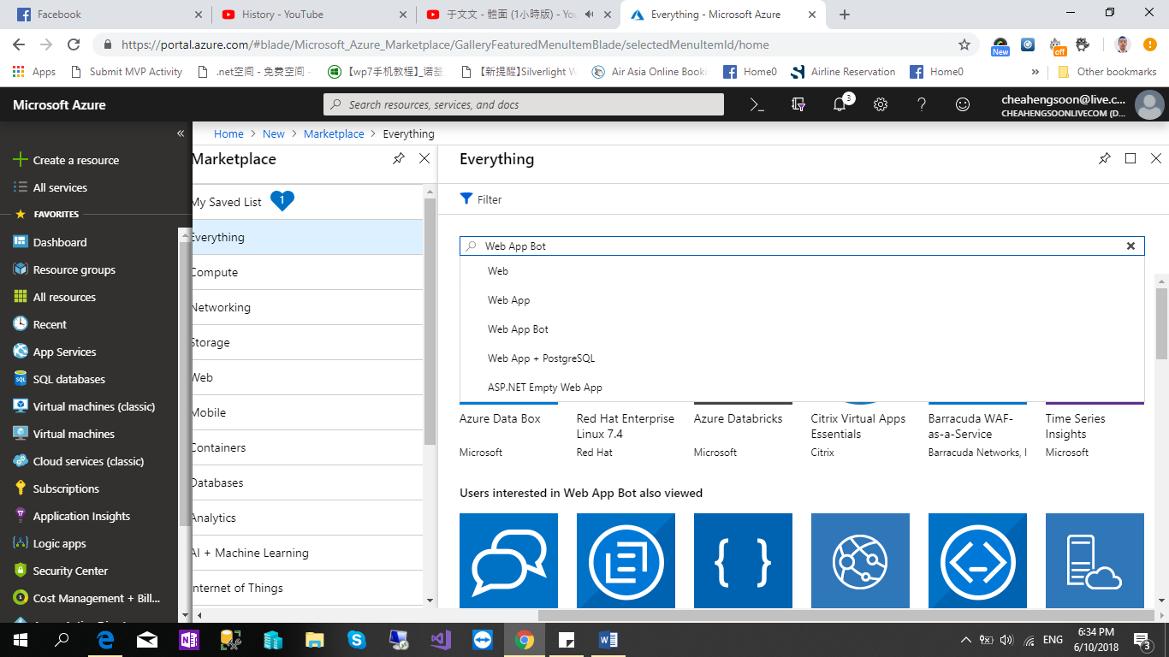

1. Select the **Web App Bot** and Click the **Create** Button.

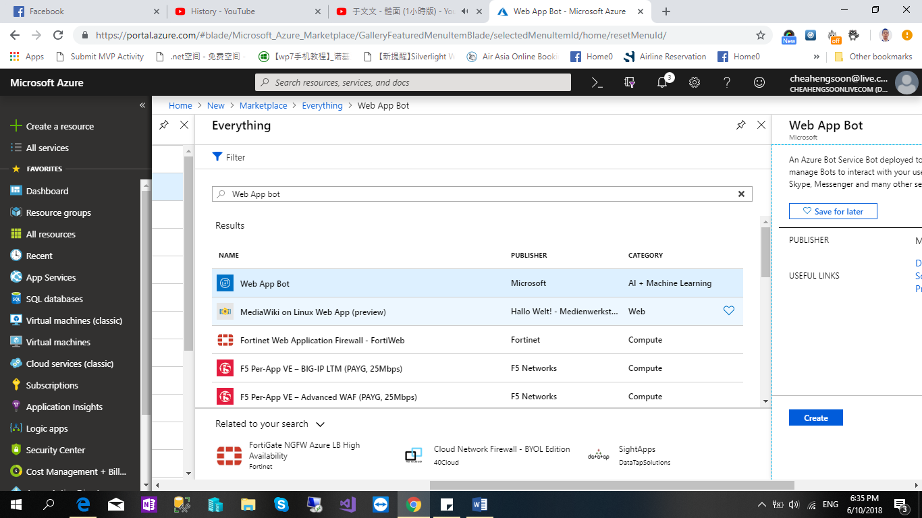

In the Bot Service blade, provide the required information, and click Create. This creates and deploys the bot service and LUIS app to Azure.

* Set App name “**deliveryBotDemo**” to your bot’s name.

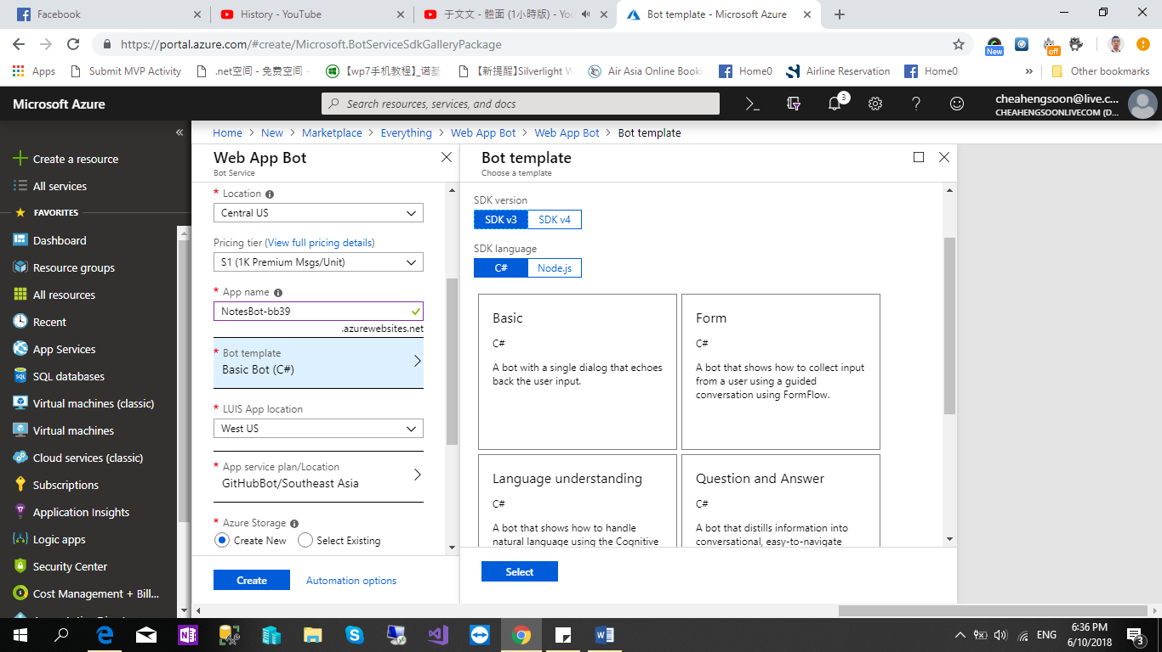

* Remember wait the “deliveryBotdemo” Deploy Finish.

1. Go to[**www.luis.ai**](http://www.luis.ai) and Sign In with your Microsoft Account. Scroll the web page and Click the “**Create LUIS app**”

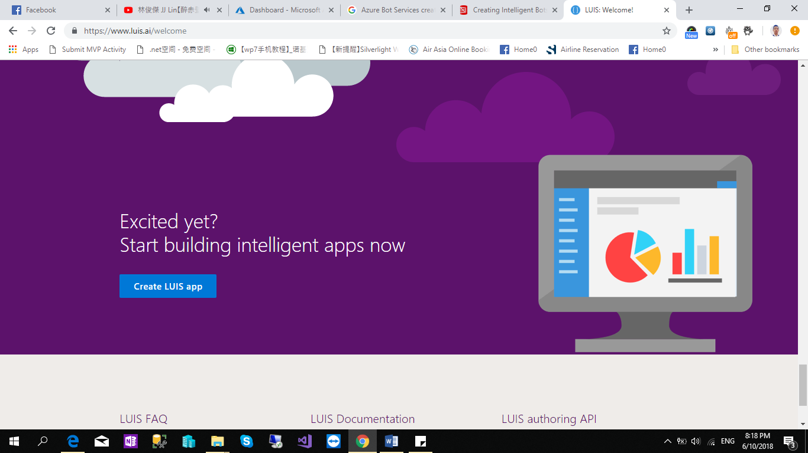

1. Select the “**DeliveryBotDemo-a778**”, the app name that you had created.

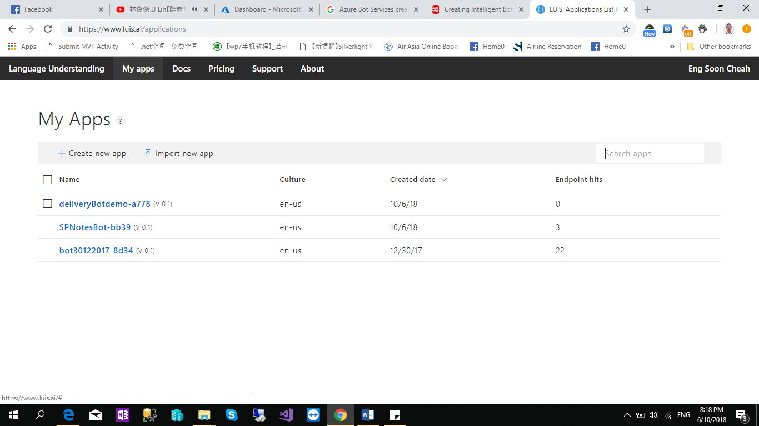

1. Select “**Create new Intent**”.

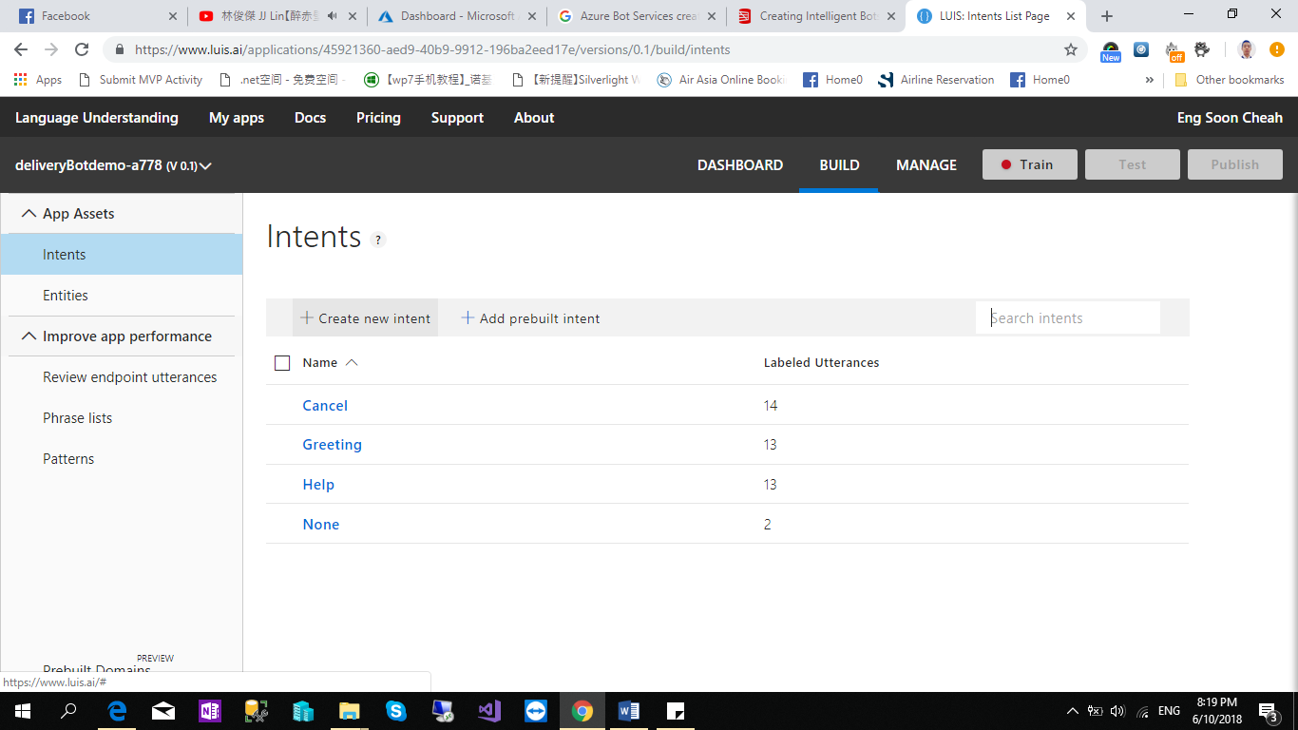

1. Give the intent Name “**SendParcel**” & Click “**Done**”

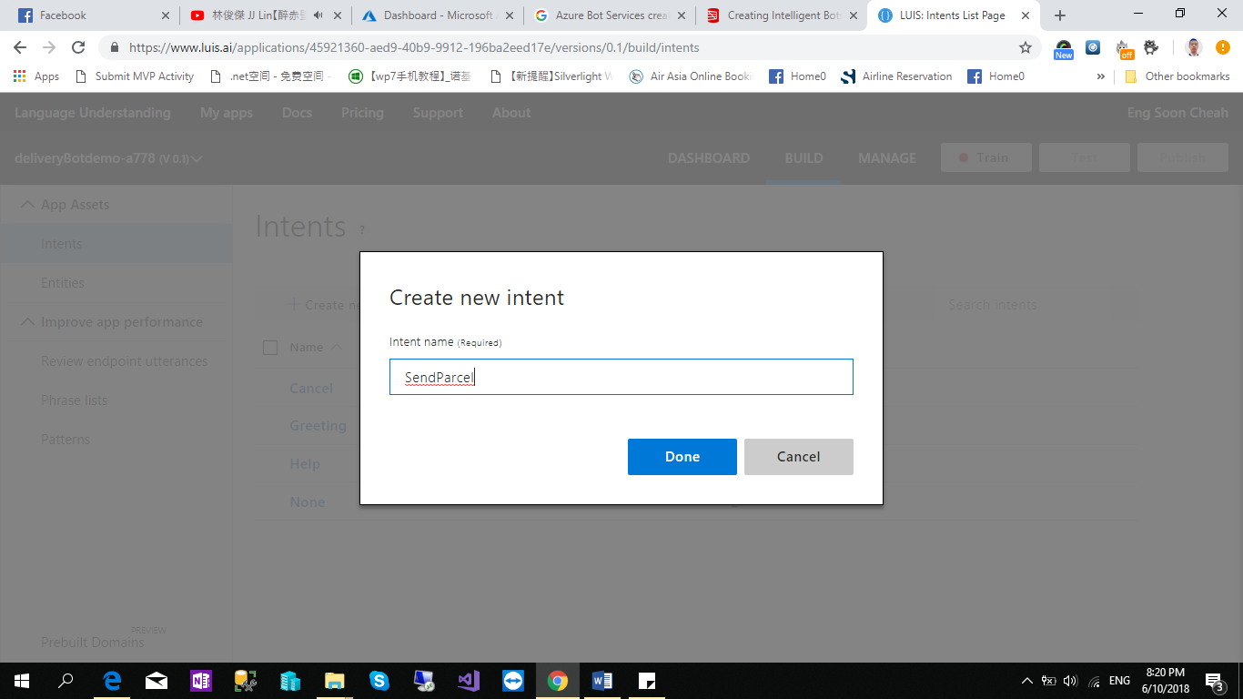

1. Now enter the **Utterances** as below.

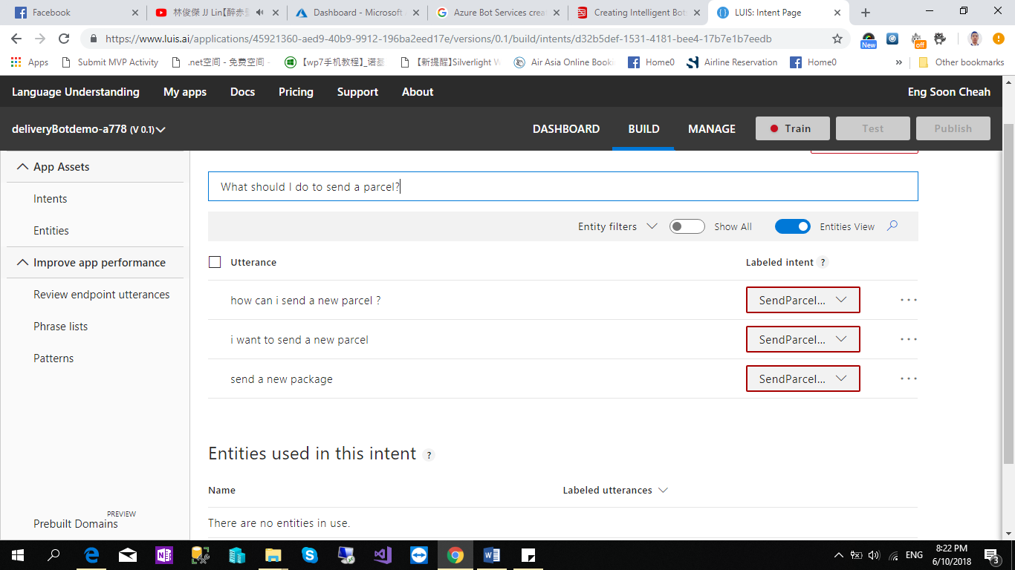

Intent name: *SendParcel*   
Utterances:

* Send a new package
* I want to send a new parcel
* How can I send a new parcel?
* What should I do to send a parcel?

Repeat the Step 6 to Step 8 for Intent “TrackParcel”.

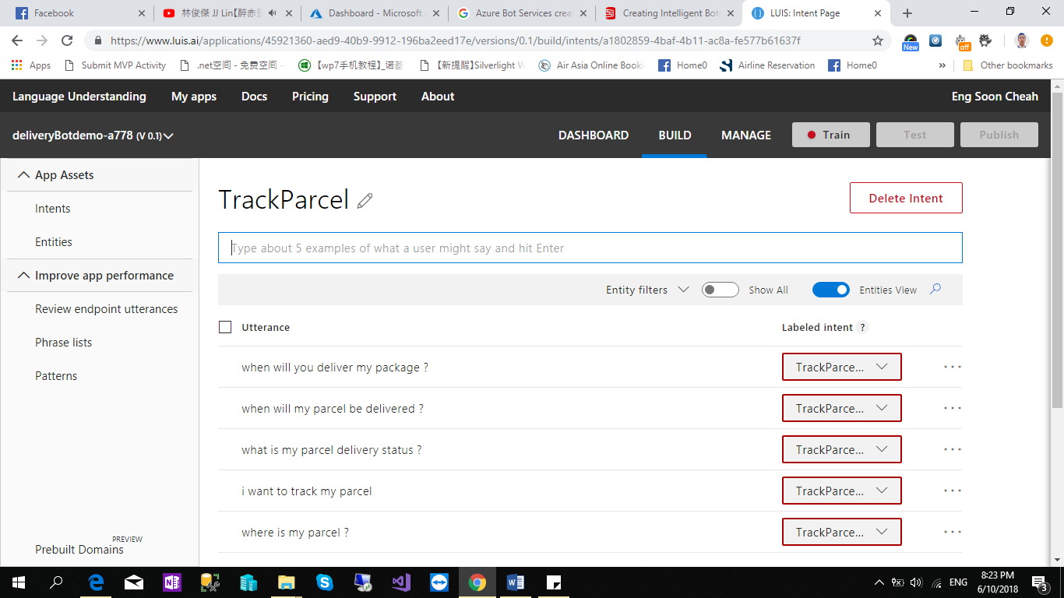

Intent name: *TrackParcel*   
Utterances:

* Where is my parcel?
* I want to track my parcel
* What is my parcel delivery status?
* When will my parcel be delivered?
* When will you deliver my package?

1. After completed with the Intent and Utterances. Click “**Train**”.

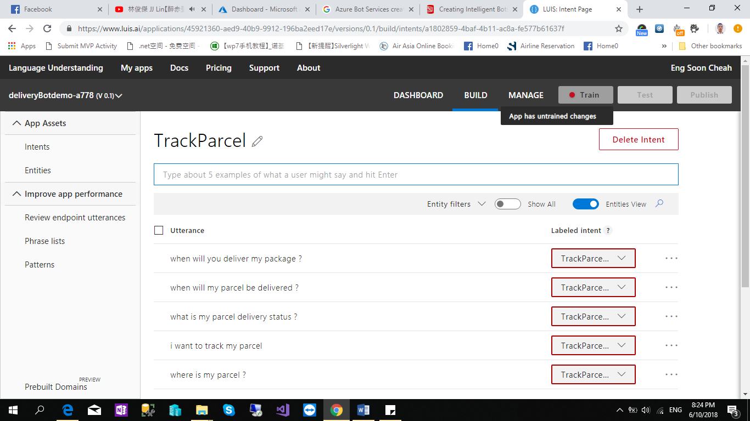

1. Now click the “**Publish**” Button and Click “**Done**” Button.

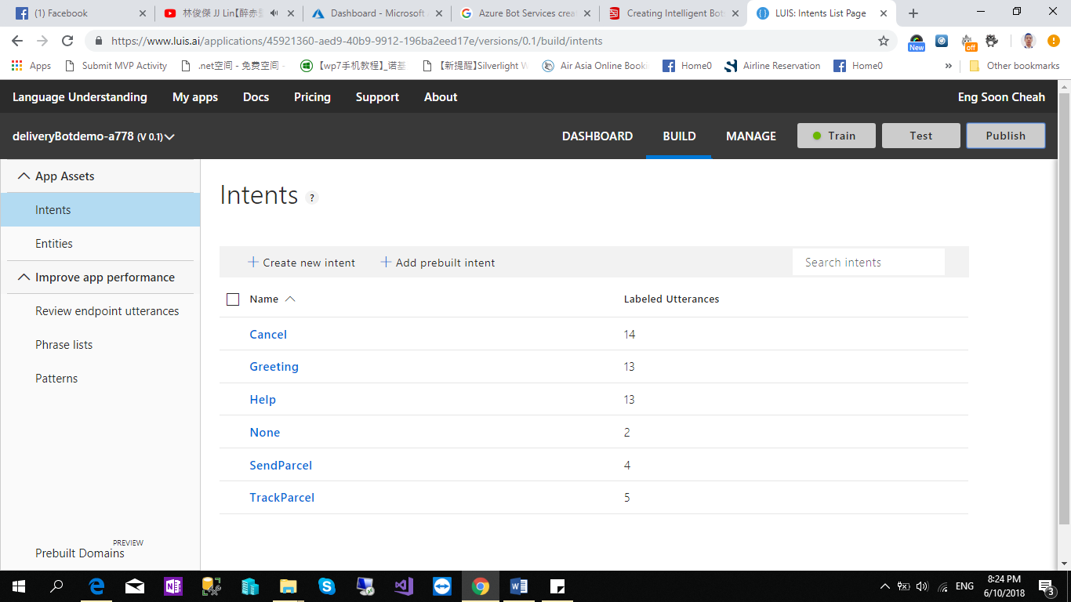

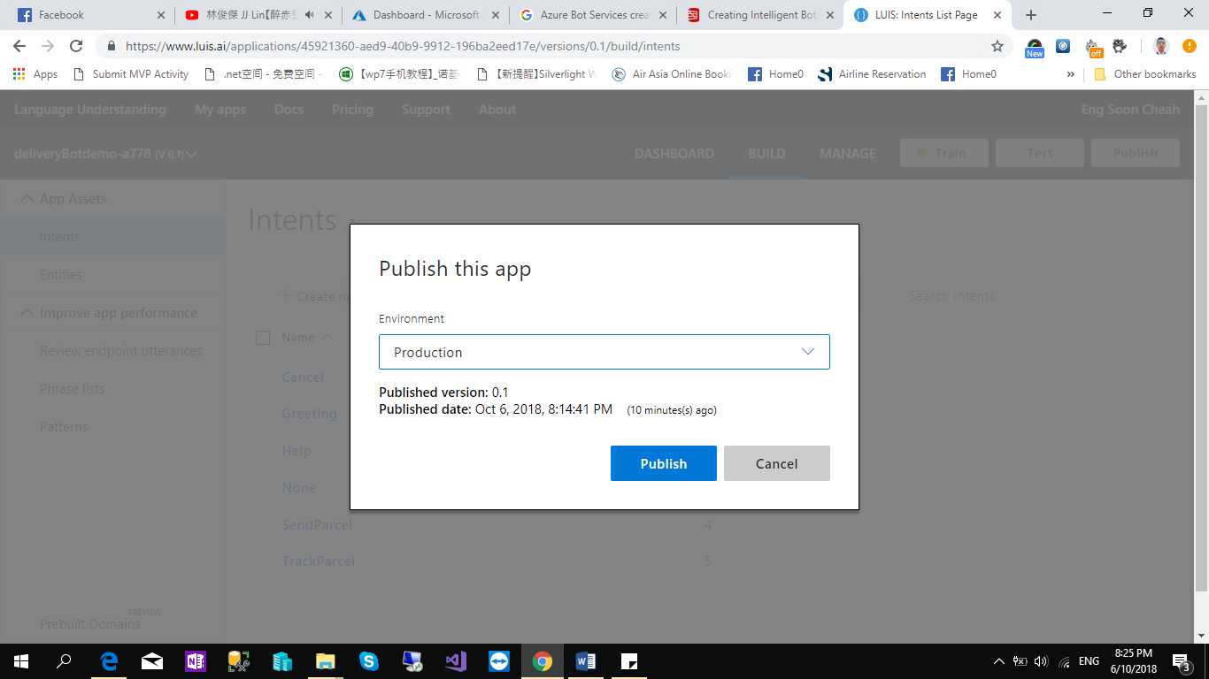

1. Go back to the **Azure Portal**. Find your Resources Group and Select your Bot.

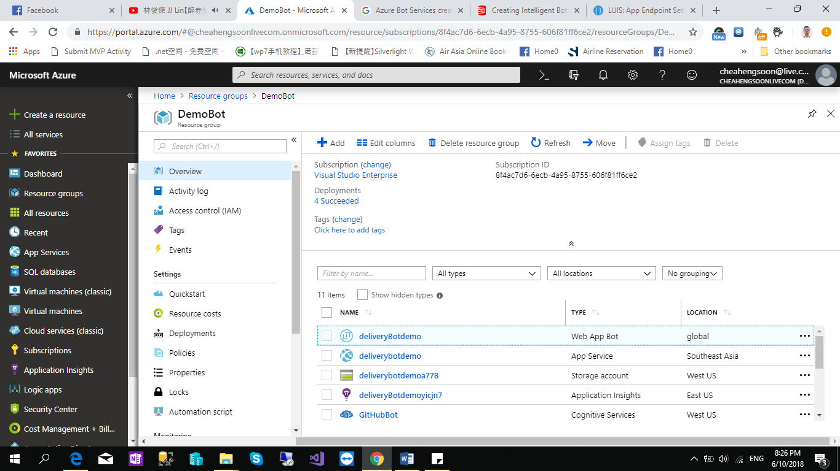

1. Select the “**Build**” and Select “**open online code editor**”

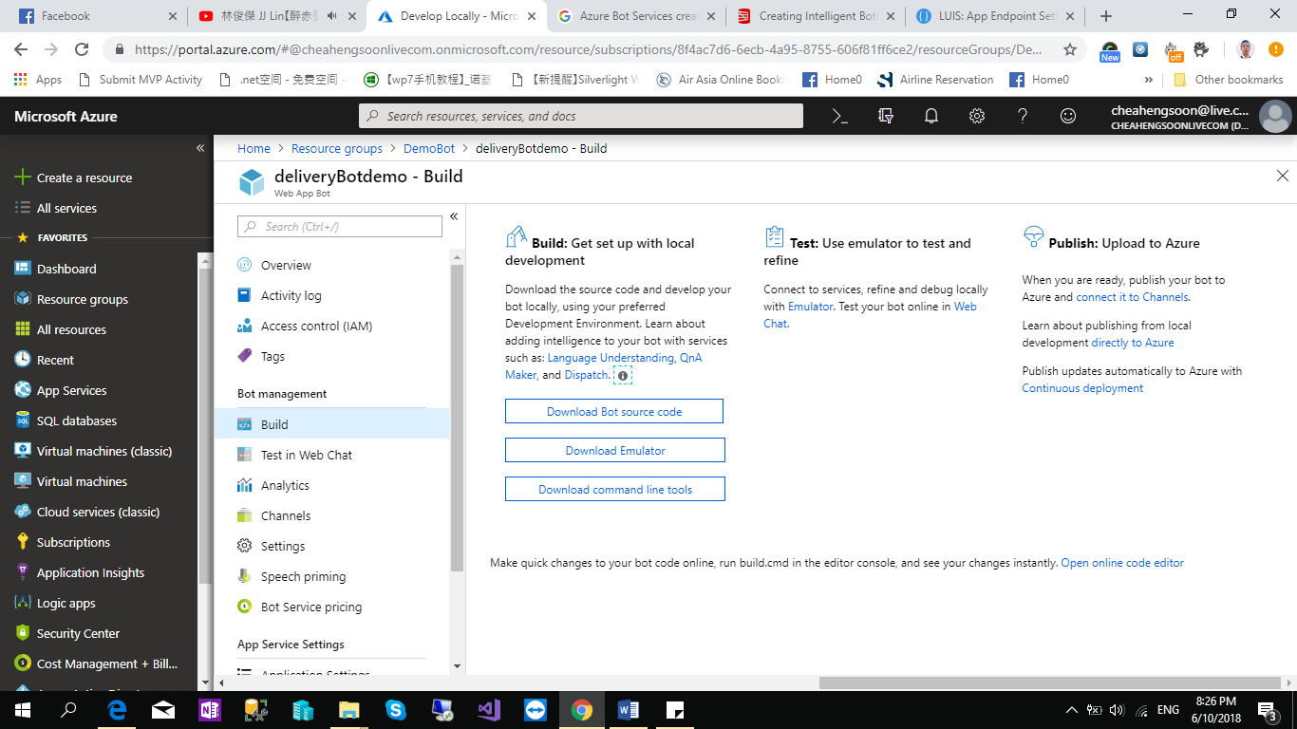

1. Go to “**Dialogs > BasicLuisDialogs.cs**” and copy and paste the code as below.

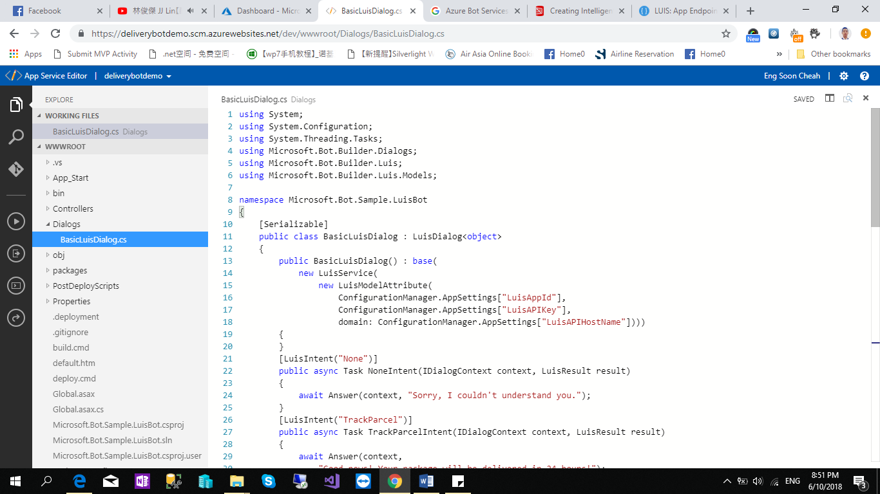

Copy and paste the code as below:

using System;

using System.Configuration;

using System.Threading.Tasks;

using Microsoft.Bot.Builder.Dialogs;

using Microsoft.Bot.Builder.Luis;

using Microsoft.Bot.Builder.Luis.Models;

namespace Microsoft.Bot.Sample.LuisBot

{

    [Serializable]

    public class BasicLuisDialog : LuisDialog<object>

    {

        public BasicLuisDialog() : base(

            new LuisService(

                new LuisModelAttribute(

                    ConfigurationManager.AppSettings["LuisAppId"],

                    ConfigurationManager.AppSettings["LuisAPIKey"],

                    domain: ConfigurationManager.AppSettings["LuisAPIHostName"])))

        {

        }

        [LuisIntent("None")]

        public async Task NoneIntent(IDialogContext context, LuisResult result)

        {

            await Answer(context, "Sorry, I couldn't understand you.");

        }

        [LuisIntent("TrackParcel")]

        public async Task TrackParcelIntent(IDialogContext context, LuisResult result)

        {

            await Answer(context,

                "Good news! Your package will be delivered in 24 hours!");

        }

        [LuisIntent("SendParcel")]

        public async Task SendParcelIntent(IDialogContext context, LuisResult result)

        {

            await Answer(context, "Please visit our website and follow the instructions.");

        }

        [LuisIntent("Greeting")]

        public async Task GreetingIntent(IDialogContext context, LuisResult result)

        {

            await Answer(context, "Hi! I'm delivery bot! How can I help you?");

        }

        [LuisIntent("Cancel")]

        public async Task CancelIntent(IDialogContext context, LuisResult result)

        {

            await Answer(context, "Cancelled!");

        }

        [LuisIntent("Help")]

        public async Task HelpIntent(IDialogContext context, LuisResult result)

        {

            await Answer(context,

                "You can ask me for parcel tracking status or to send a new one :)");

        }

        private async Task Answer(IDialogContext context, string message)

        {

            await context.PostAsync(message);

            context.Wait(MessageReceived);

        }

    }

}

1. Select the build icon and type the command “**build.cmd**”

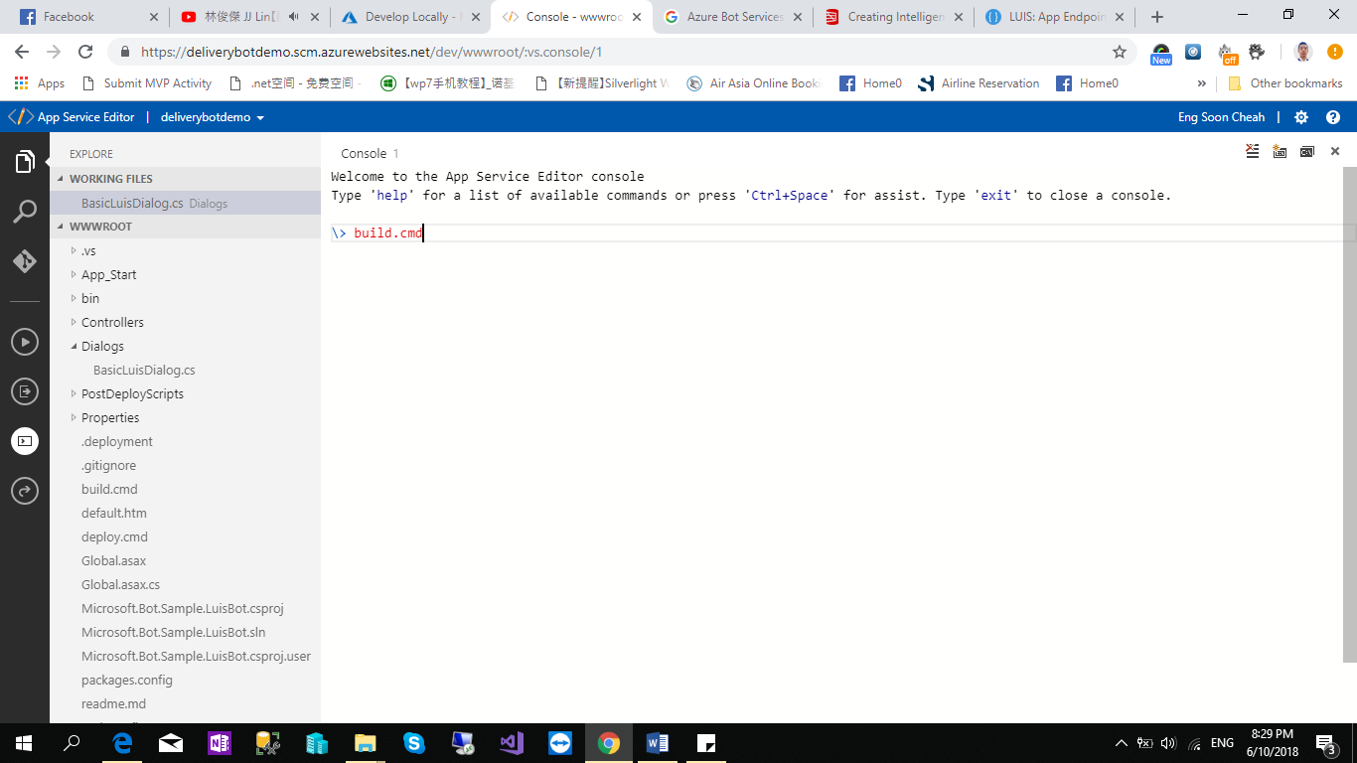

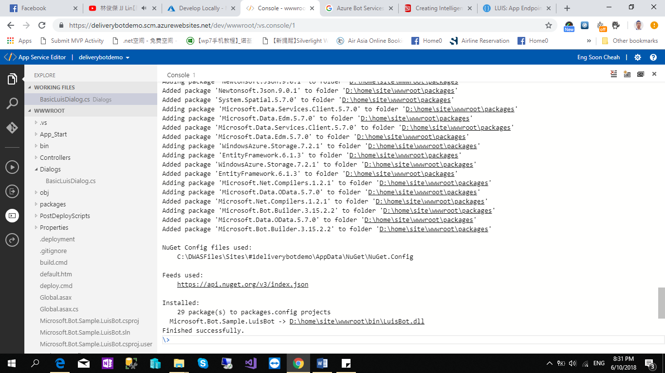

1. Go to “Test in Web Chat” and Test you chat bot.

